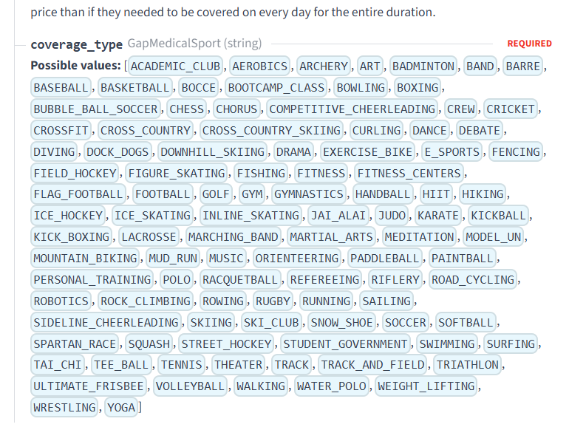

Hide the following:
Bootcamp_Class
Bubble_Ball_Soccer
Crossfit
Dock_Dogs
Exercise_Bike
Fitness
Figure Skating
Fitness_Centers
Gym
Handball
HIIT
Hiking
Jai_Alai
Martial_arts
Meditation
Model_UN
Mud_Run
Orienteering
Paddleball
Paintball
Personal_Training
Polo
Raquetball
Refereeing
Road_Cycling
Rock climbing
Running
Ski Club
Snow_Shoe
Spartan_Race
Tai-Chi
Tee-Ball
Triathlon
Walking
Ski Club
Street Hockey
Track (we will show Track & Field)
Yoga

